Arduino DC Motor with Ultrasonic Sensor

By: Matthew Jourden Brighton High School Brighton, MI

1. Navigate to TinkerCAD > Create the following circuit > Circuit > Create a New Circuit > Rename to DC Motor w/Ultrasonic

DC Motor

1. DC Motor has two wires
   1. Red Wire: Voltage wire that can be
      1. wired into the 5V turning the motor on with no off switch unless a switch is wired in front of it
      2. wired to a digital port, allowing the user to turn the motor on and off using
   2. Black Wire: Ground Wire

Motor Movement: DC Motor states

* High: Full Speed
* Low: Stopped
* Variable: With a transistor, diode and potentiometer DC motors can be variable speed and direction

1. Wire the following circuit

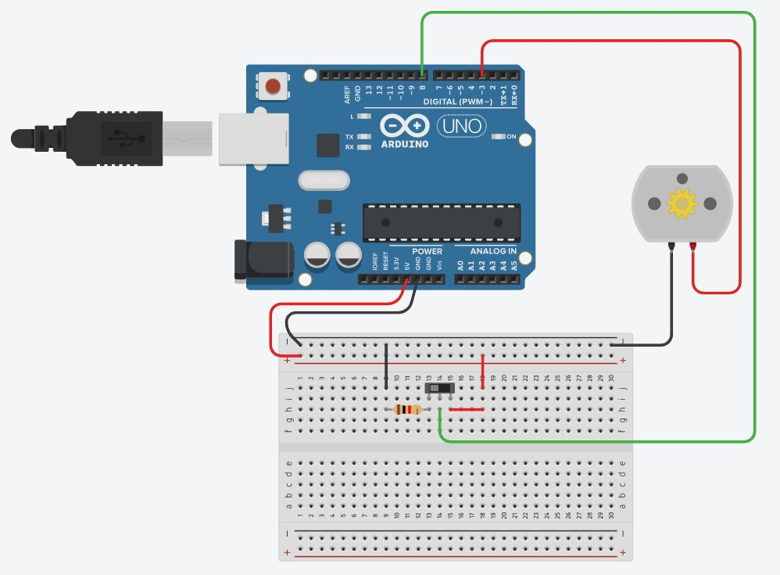

1. Write the following code

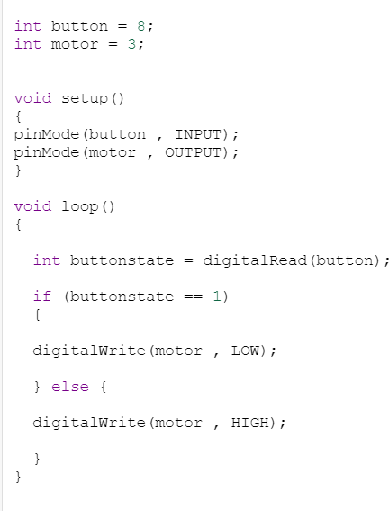

1. Run the Simulation Test > Test the motor turning it On and Off

**Ultrasonic Sensor**

# Ultrasonic Sensor is designed to send out a sound wave signal called the Trigger; and receive the bounced back sound wave into the Echo port. The sound wave will pulsate the Trigger on and off so the sound wave returning from the contacted object will be able to pass between the pulses. If the Trigger was constantly on the returning sound wave would be distorted.

Trigger Sound Wave will be a conical shape and can be distorted from ambient noise and materials that absorb sound (i.e cardboard, tennis ball, etc.)

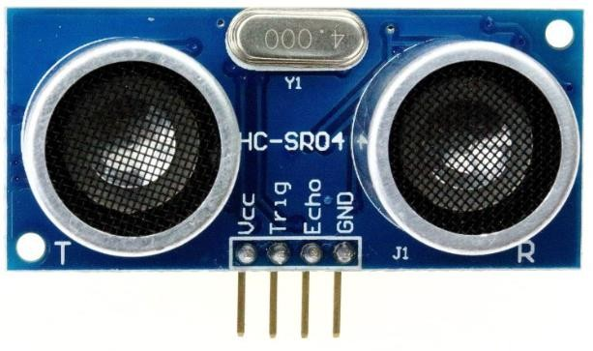

Trigger (trig)

Echo

Sound Calculation Formula: Distance L = 1/2 × T × C

where L is the distance, T is the time between the emission and reception, and C is the sonic speed. (The value is multiplied by 1/2 because T is the time for go-and-return distance.)

1. Add the Ultrasonic Sensor to the Circuit as shown

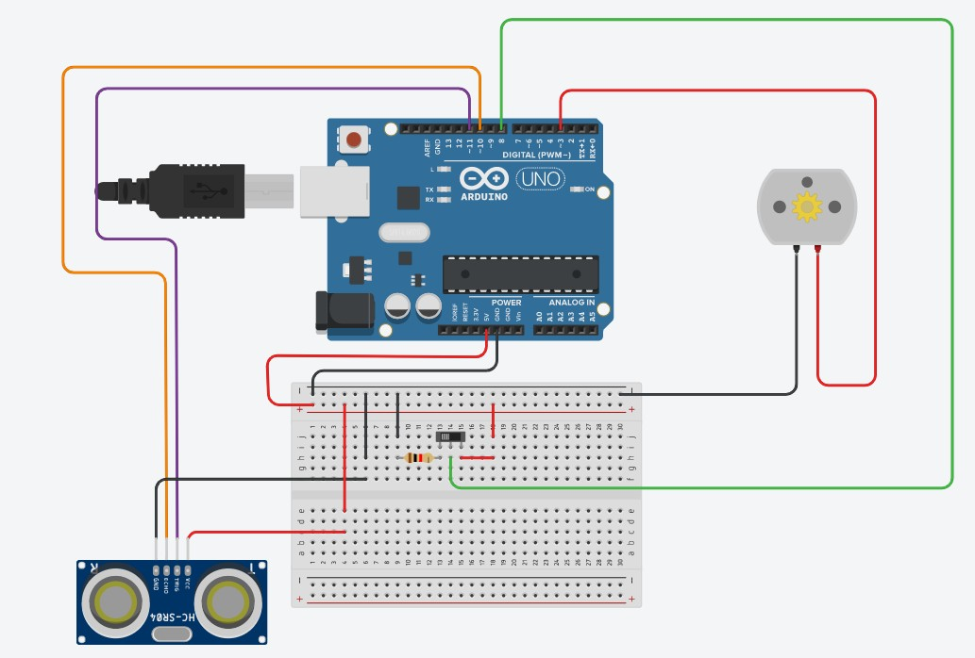

1. **Write the following Program**

Function: The following program will also use a function to help consolidate the code that will be used to turn the ultrasonic sensor on/off and convert the sound wave value to measureable unit in inches.

Function Example (See Reference Document Function for more details.)

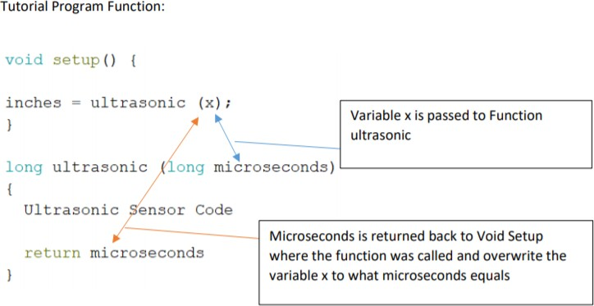

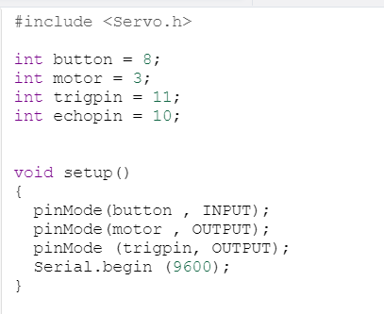

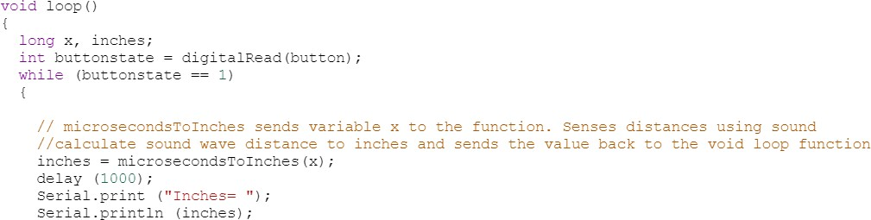

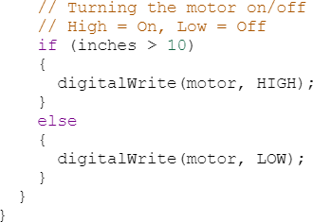

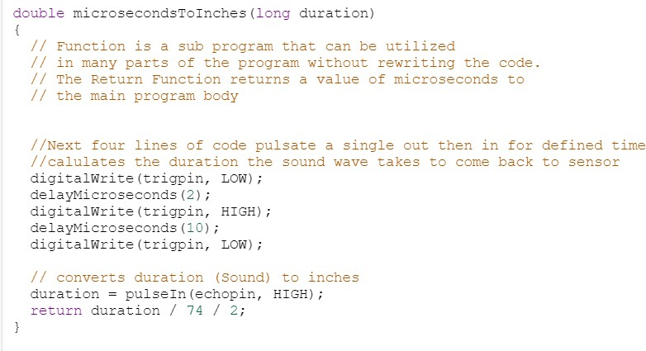

1. Run the Simulation Test button and the ultrasonic sensor

How to Work the Ultrasonic Sensor > Select Ultrasonic Sensor > Drag the blue location dot that represents an object

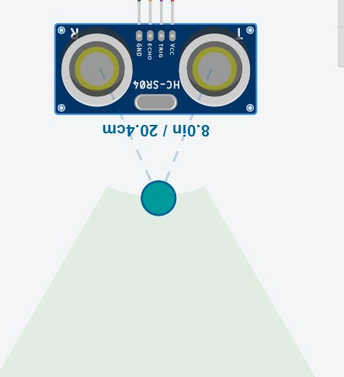

Represents Object > Hold Left Mouse Key on object and drag

Cone in which the sound wave can be seen

Shows Distance

Assignment: Add the following components and add code to the program

* 1. Add a push button that represents Emergency Stop
     1. Activated only when in the Object is out of range with the ultrasonic sensor
     2. When pressed Motor will stop
     3. Attach a Speaker (See Reference Document Piezo) Will sound error sound; use Piezo Speaker (NOTE: noTone (“DIGITAL PORT#”); will turn off the piezo speaker
  2. Distance Reactions
     1. Object: Less than 8in and greater 125”
        1. RGB LED: RED Color
        2. Output in Serial Monitor: Error! Out of Range NOTE: Only output 1 time
        3. Sound Piezo speaker until Emergency Button is pressed then turn off piezo speaker
        4. Stop Motor
     2. Object: Object< = 15 or Object>=100
        1. RGB LED: Yellow Color
        2. Output in Serial Monitor: Caution!!
        3. Motor Runs
     3. Object: Object > 15 and Object < 100
        1. RGB LED: Green Color
        2. Output in Serial Monitor: Within Operating Range
        3. Motor Runs

**Submission:** To Submit TinkerCAD Tutorials and Assignments: Select Share Icon (Top Right Corner) > Select Invite People > Copy URL > Navigate to Student Email Account > Compose a New Email > To: [jourdem@brightonk12.com](mailto:jourdem@brightonk12.com) > Fill Subject Heading TinkerCAD "Tutorial or Assignment" "Tutorial/Assignment Name" > Send